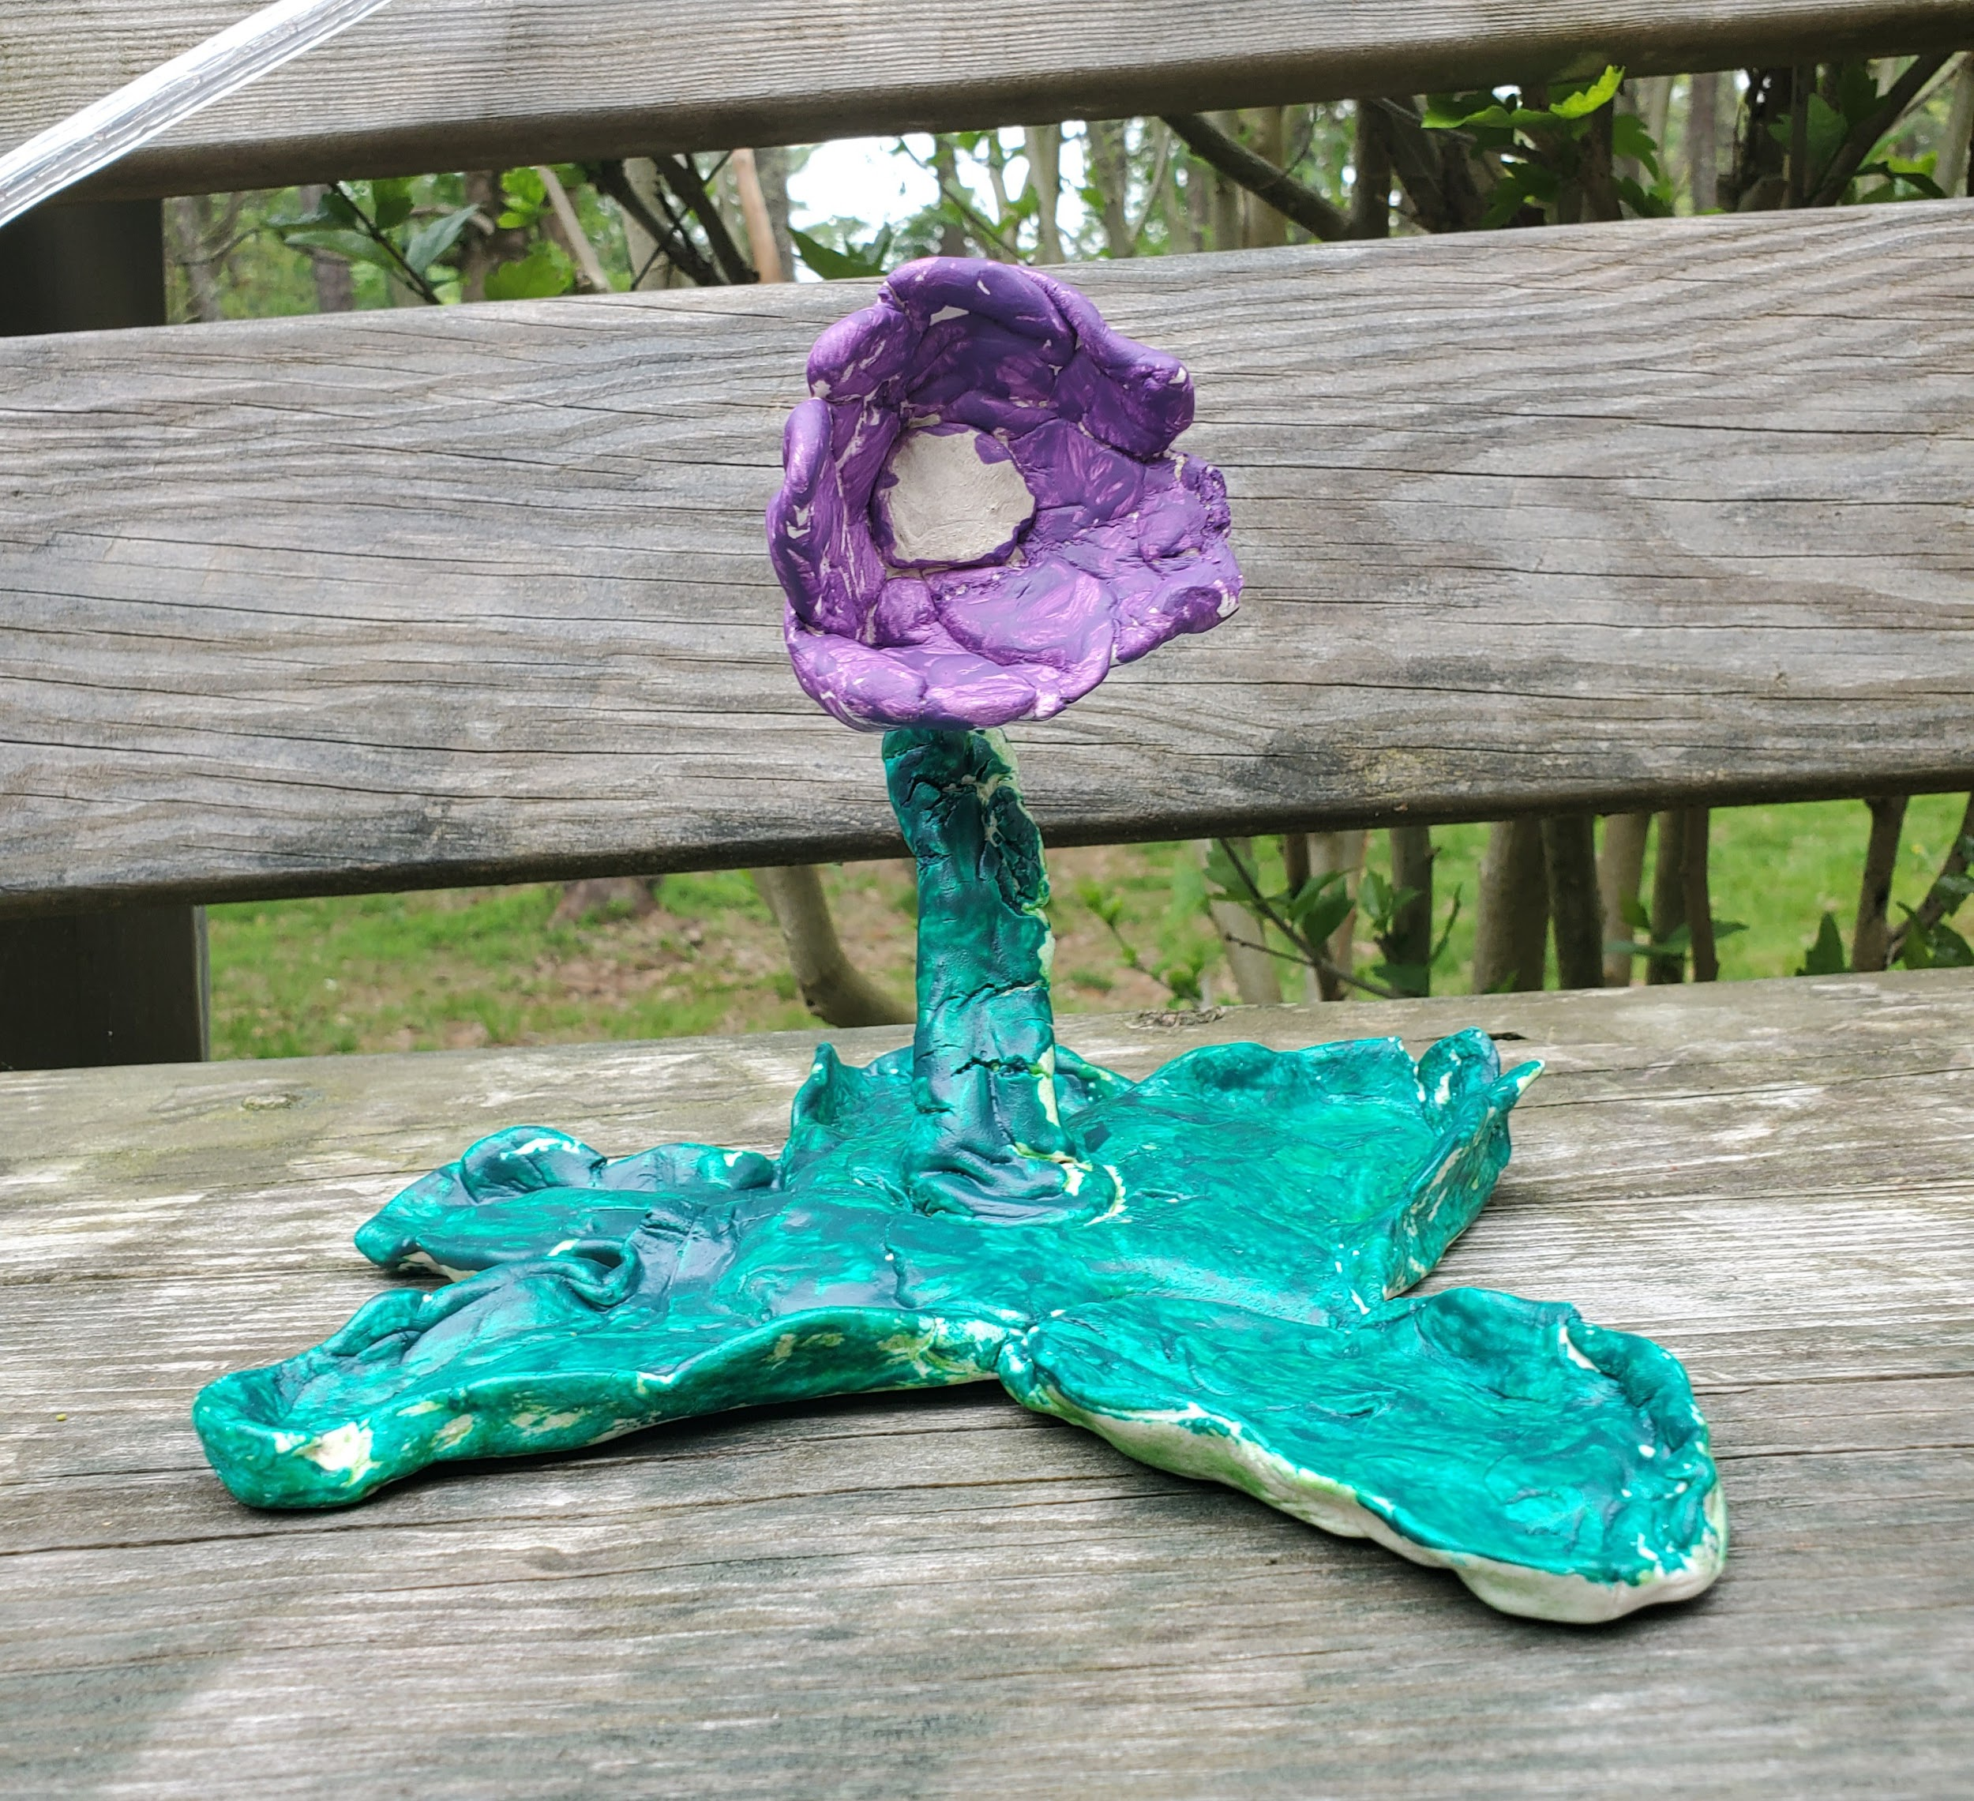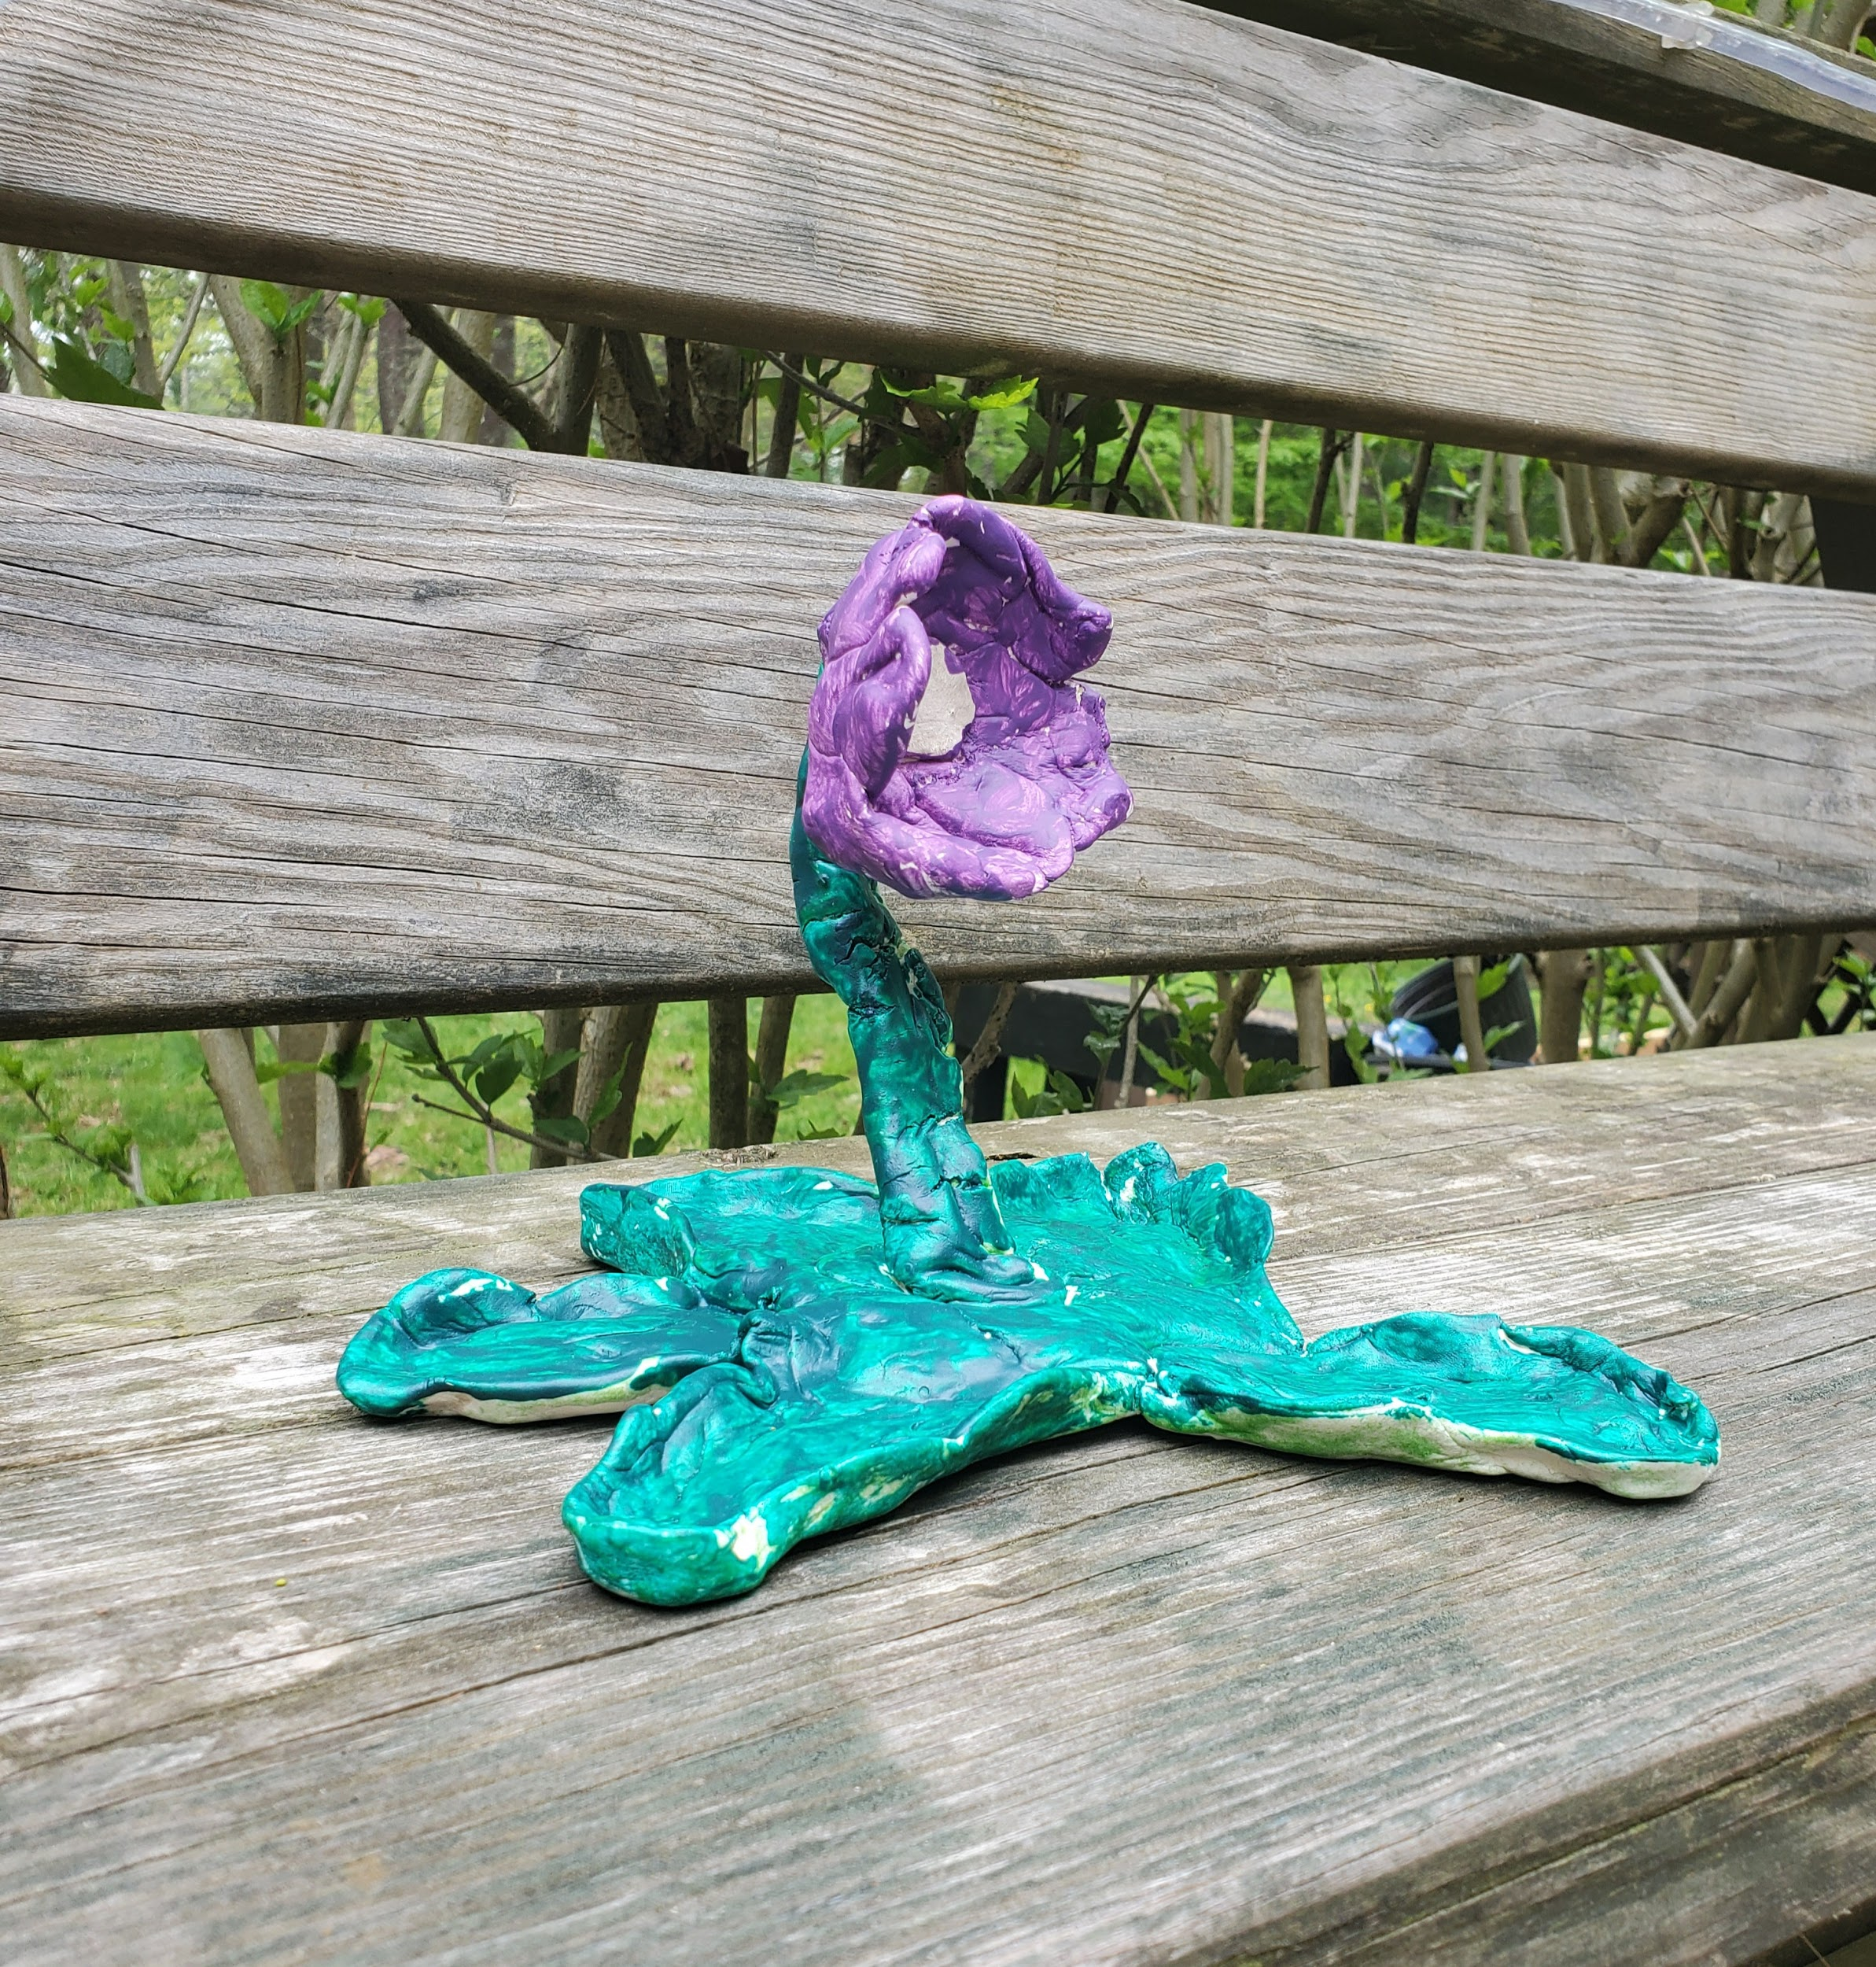

I’m a little butterwort No Butter on my Butterworts

How I get my energy?  From the sun  I can make fake dew  Meal time is done  When I catch a big bug  On my leaves  He tries to fly off  But he can’t leave | No butter on my butterworts  I have 5 petals on my stem  My soil is poor, I eat insects instead  No butter on my butterworts  We live in Scotland, Wales and Ireland  We don’t have teeth, how do we chew our insects?

Introduction in Diné Bizaad: Yá'át'ééh!

Ending:
Butterworts also live where some of my family lives, around the Great Lakes and Canada. Part of my family is Ojibwe.
We believe that all created things have a spirit and a gift. The gift plants have to give are medicine for healing and food to keep things alive.
We must be thankful to them and treat them with respect for the gifts that they give to us. We should also sing and talk to our plants and gardens.
I zoomed with Mrs. Elaine Fleming, a teacher at Leech Lake Tribal College in Cass Lake, Minnesota. She told me that this butterwort will be lonely if it is by itself- I can grow another to keep it company by saving the leaves and planting it.

Notes on butterworts: (just in case)
Different species of butterworts grow in different places around the world.

Butterworts dissolve bugs with enzymes to digest them.

Sources:
The Wildlife Trusts Website: https://www.wildlifetrusts.org/wildlife-explorer/wildflowers/common-butterwort
Lawrence, Ellen. Meat-Eating Plant, Toothless Wonders, 2013.

Facts for Song Rhyming Words

Live in Canada (Habitat) | Rat, sat, mat, fat, cat
Sticky glue on petals | Poo, dew, do, new, kazoo, ew
Deep purple petals | Kettles, nettles, metals, settles
Poor soil | Foil, spoil, royal, loyal
Get energy from sun | Bun, fun, one, won, run, undone
Make fake dew | Rake, make, cake, lake, mistake,
Means” little greasy one” in latin | Satin, clappin’ , catchin’
Eats small ‘choish’ (insects) | Call, haul, hall, tall

